School of Environmental Sciences
Department of Mining and Environmental Geology
STUDENT NUMBER | 11602169
FULL NAMES | MBEDZI ADAM
COURSE | MEG3641: EXPLORATION AND MINING GEOLOGY
LECTURER | PROF. J.S. OGOLA

TOPIC: WITH A WELL LABELLED DIAGRAM, EXPLAIN HOW CORE LOGGING IS CONDUCTED

CONTENTS
- INTRODUCTION……………………………………………………………………………………………………. 2
- EQUIPMENT USED IN CORE LOGGING…………………………………………………………………. 2
- PROCEDURES OF CORE SAMPLING………………………………………………………………………. 2
  - CORE HANDLING………………………………………………………………………………………. 3
  - WATERING……………………………………………………………………………………………….. 3
  - DETERMINATION OF CORE PROPERTIES………………………………………………..... 3
  - CORE RECOVERY………………………………………………………………………………………. 3
  - DETERMINE THE ROCK QUALITY DESIGNATION (RDQ)…………………………….. 3
  - RECORDING GEOLOGIC DESCRIPTION……………………………………………………… 3
  - CORE CUTTING…………………………………………………………………………………………. 3
- CONCLUSION……………………………………………………………………………………………………….. 4
- REFERENCE…………………………………………………………………………………………………………… 5

- INTRODUCTION
Core logging refers to analysis of strata by means of drilled core samples at sequential depth intervals as the well is drilled and geological observations of the core are recorded on paper or computer. A core is a sample obtained by drilling a tabular segment of rock, ice or other materials obtained as a study sample by drilling (McGraw-Hill, 2003).
- EQUIPMENT USED IN CORE LOGGING
- Core log sheet containing borehole number, total length of borehole, date, location, level number, block number. It is used to record information obtained during determination of core properties.
- Indelible-felt tip marking pens – used to mark lithological contacts.
- Core tray - for packing the core after drilling.
- Tray stand - supporting core tray.
- Water pipe – providing water for washing core to ensure core visibility during analysis.
- Hand lens – used for magnification during analysis.
- Calculator – to easy the calculations of core recovery, core loss, and rock quality designation.
- Clino-ruler - to measure length of core in each row, and the sum of all rows is the total core recovery.
- Steel nail - for determining the hardness of the minerals on the core.

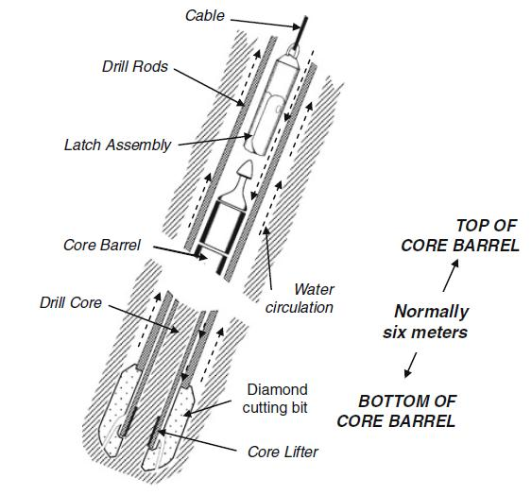
- PROCEDURES OF CORE SAMPLING

Figure 1: Illustration the process of core drilling.

The first step is to make sure everything required for core is there and in proper order by obtaining drilling specifications. Obtain borehole coordinates by using GPS receiver/survey pegs if underground, and establish the unit of measurement that will be used (feet/inches, tenths of feet, meters, etc.).
  - CORE HANDLING
Remove core section from core barrel and place it in core tray and/or storage location, then
insert core section place markers (e.g., wood blocks, bags of rubble, etc.) as place markers for unrecovered core and start and stop of core run. Label core sections with orientation mark (i.e., direction of drilling) and hole footage.
  - WATERING
First step in core logging is watering the core using a pipe providing clean uncontaminated water. Watering wets the core, enhances mineral visibility when viewing with hand lens, removes unwanted dust and makes core labels to be visible.
  - DETERMINATION OF CORE PROPERTIES
The core is scratched using a steel nail to determine the hardness and possible minerals i.e. scratchable zones show presence of soft minerals such as talc and hard zones show presence of hard minerals. The optical and physical properties of the core e.g. rock colour, texture, hardness, cleavage, foliation, grain size are also determined and contacts between lithologies are identified.
  - CORE RECOVERY
Percentage core recovery is determined by using clino-ruler to measure the length of core in each row and the sum of all the rows will give the total core recovery. Dividing the actual length of core recovered by run advance and multiplies the result by 100 and Record in "% Recovered" column in the core log sheet. Any recovery in excess of the core cut should be reported, as well as non-recovery. Assign non-recovery and over-recovery to the bottom of each core, unless some special observation indicates that an exception should be made. All such exceptions should be noted.
  - DETERMINE THE ROCK QUALITY DESIGNATION (RDQ)
The RQD is a modified core recovery percentage in which all the pieces of sound core over 4-inches (100-mm) long are summed and divided by the length of the core run. Thus, it is simply a measurement of the percentage of "good" rock recovered from an interval of a borehole (Stagg and Zienkiewicz 1968).
  - RECORDING GEOLOGIC DESCRIPTION
Record the geologic description and any unusual or distinct features. Include, as appropriate, the following information in the description column on the log sheet: Rock type, Grain/crystal size, Minor constituents, Bedding, and Rock structures.
  - CORE CUTTING
Exploration core portions to be sampled are cut into half using a diamond saw machine. One half of the sample will be retained while the other half is sent for assay. The retained sample will be kept and used for verification of unexpected results and used for future reference.

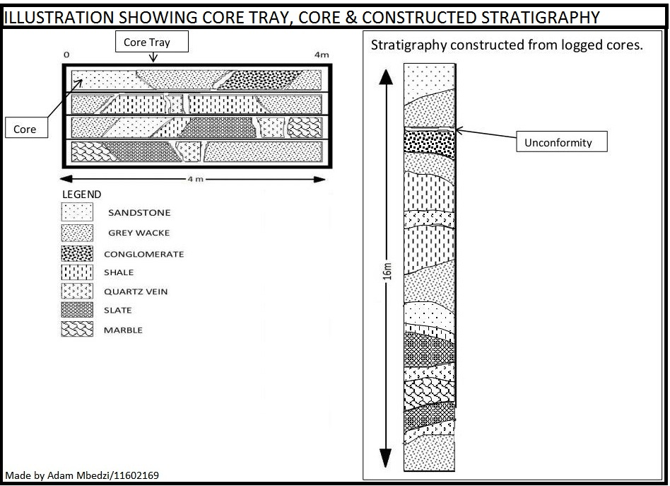
Figure 2: An illustration of core tray, core and constructed stratigraphy after analysis.

- CONCLUSION
After conducting core logging, the extent of mineralisation is known and sampling takes place. When sampling is done, assaying follows which will determine whether to mine the area were the core was drilled or not. Drill core offers the most complete sampling of rock encountered in the subsurface. Sidewall core allows for some reservoir data but yields an incomplete picture of the rock structure, with little sed-strat applicability. Drill cuttings (chips) yield insight into mineralogy or lithology texture but none on structures offer poor vertical resolution and are too small to be used for assessing reservoir properties. Unlike in hard-rock exploration, geophysical tools do a reasonably good job assessing rock character, lithological variation is more constrained and core samples cannot be retrieved without “tripping” the drill-string. This adds up to time, money and declining returns. The combination of core and logs allows for data to be extrapolated laterally to other locations once the logs have been ground trothed.

- REFERENCE
Stagg, K.G. and Zienkiewicz, O.C., (1968), Rock Mechanics in Engineering Practice, Wiley, N.Y., 442 pp.
MacGraw-Hill, S., (2003), Dictionary of scientific and technical terms, MacGraw-Hill Companies, USA.

