DEPARTMENT OF MINING AND ENVIRONMENTAL GEOLOGY
ELANDSFONTEIN COLLIERY MINE VISIT REPORT
STUDENT NUMBER : 11602169

FULL NAMES : MBEDZI ADAM

COURSE : MEG 3547

LECTURER : MR MAIYANA A.B.

CONTENTS………………………………………………………………………PAGES

- Introduction………………………………………………………………………………………. 2
- Purpose of the visit……………………………………………………………………………. 2
- Geology of the area……………………………………………………………………………. 3
3.1. Stratigraphy………………………………………………………………………………… 3
3.2. Mine water evolution…………………………………………………………………. 4
- Mining method and commodity………………………………………………………… 4
- Production operation………………………………………………………………………… 5
- Conclusion…………………………………………………………………………………………. 6
- Recommendations…………………………………………………………………………….. 7
- References…………………………………………………………………………………………. 8

- Introduction
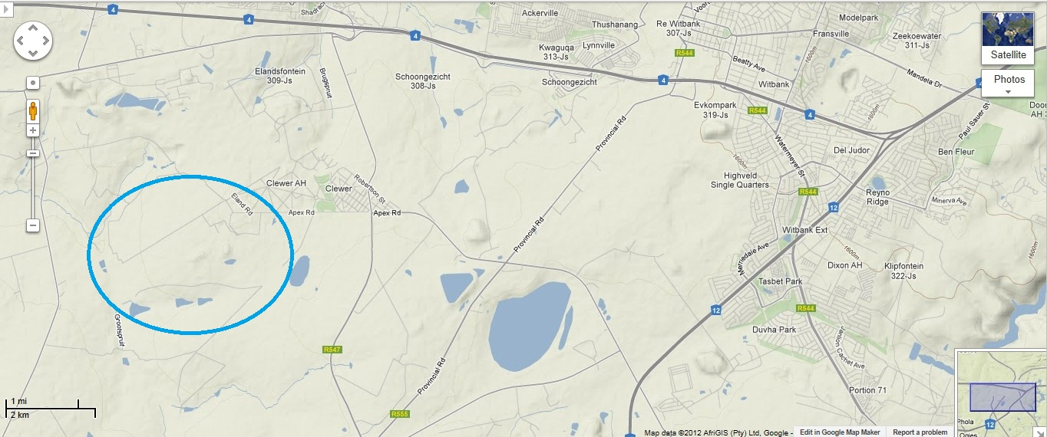
The visit as a whole was aimed at visiting the Elandsfontein Colliery Mine as a whole or one operation and its sectors. The operation relates to or otherwise corresponds to a medium-scale operation. Elandsfontein Colliery Mine is located in the south-west of Witbank near Clewer found in the western part of Mpumalanga Province. The area is actually categorized under the Witbank Coalfields and partly of the Highveld Coalfields of Mpumalanga, South Africa where most of the country’s coal is recovered, and the mine is owned by Anker Coal and Mineral Holdings SA (Pty) Ltd. The operation is in a farm, and besides it is also surrounded by very sensitive areas, these include the Witbank Nature Reserve, Ezemvelo Private Nature Reserve, Clewer residential area and others. The area encircled in the map below is where the Elandsfontein Colliery Mine operations are located.

Figure 1
- Purpose of the visit
The main purpose of the visit was to explore the mining operation as to relate with acquired academic knowledge from different sectors in a mine as presented in each specificity of the module content up to our level of study but with special attention to those that relate closely to integrated mine water management as a module. This was also to familiarize us with the practical world of our degree as a whole, in order to facilitate the comprehension of all theoretical implication of the mining operation as a system and all its related sectors. In addition, the visit was also a means of acquiring new information that cannot be expressed theoretically which is useful for our educational development and career advancement; this was also to give us the recent information or otherwise current challenges that are not yet documented as to how to address them or how they are generated. The secondary purpose was to enhance our interests as graduates to our working environment as future professionals and also to improve the way we relate to each other in the field.
- Geology of the area
The geology of Mpumalanga Province as a whole is very much of economic importance as it is characterized by vast majority of geological formation and complexes with distinct features such as Barberton greenstone belt, Bushveld Igneous Complex and others, but the main focus on this will be that of the stratigraphy of the Witbank Coalfield and Highveld Coalfields, and as attribute to integrated mine water management as a module, the mine water evolution of the Highveld Coalfields will also be discussed to review the changes in approach to mine water management of the area.

  - Stratigraphy
The Witbank Coalfield is situated east of Johannesburg, and Highveld Coalfield is situated south of the Witbank Coalfield. The fields are characterized by numerous post-Karoo age dolerite sills and dykes, and rocks of the Vryheid Formation of the Ecca Group cover most of the area. Five separate bituminous coal seams are preserved in the Vryheid Formation, deposited under cool, wet climatic conditions. The Witbank Coalfield consists primarily of sandstone, carbonaceous shale, siltstone and minor conglomerate. The sediments were deposited on an undulating floor, which influenced the distribution and thickness of the sedimentary successions as well as the quality of coal seams. The distribution of the coal seams is controlled by the pre-Karoo topography, but the coals are mainly flat-lying or dip only slightly in a southerly direction. Steeper dips are encountered in the lower seams, while seams numbers 4 and 5 have a regular deposition. The strata of the Karoo are generally undeformed, but have abundant small faults. Dolerite dykes and sills have affected most of the areas of the coalfields. Large sections of the coal seams have been devolatilized, and are rendered inapt for mining purposes (Smith and Whittaker, 1986).

  - Mine water evolution
Highveld Coalfields is located within the Upper-Olifants River Catchment, and this is one of the 18 strategic water management areas of South Africa. Coal mining is actually concentrated in this catchment area, and the impacts originating from this part of the catchment will propagate down the river and may influence the downstream water users. The approach and practice of mine water management in the Highveld Coalfields of Mpumalanga have changed and evolved substantially over the past 30 years. When coal mining started more than a century ago, water was approached as something to be avoided in the mining operations. When the large opencast mines were constructed and commissioned in the late 1970’s and 1980’s, water was considered in mine planning, but the full impact of water on mining was not appreciated and recognized. Recently, the focus has shifted and mine water is now considered as critical to the management of a mining operation and main impact on the public and regulatory approval of the license to mine. In the evolution of mine water management, it became clear that the key drivers include the local Olifants River Catchment perspective, the type and extent of the coal mining operations, the changing environmental and water related legislation and regulations and technology advances (Mey and Van Niekerk, 2009).
- Mining method and commodity
The mining methods at Elandsfontein Colliery Mine vary from surface to underground controlled by the depth at which the commodity is mined and the variations of its thickness with respect to varying localities. The commodity mined is coal and is found in terms of beds, also called seams. At areas where this coal seams is at a depth of approximately thirty meters beneath the surface, a surface mining method called open-cast is used where the overburden is stripped off by excavators and of consolidated material, drilling is applied as a method of rock breakage. The waste rock and other materials such as soils are used to backfill the excavated areas at which two pits have been backfilled in this mine and another pit is actually under operation where the current coal is recovered in the mine, the coal at this pit is associated with the beds of sandstone and black shale at a depth of approximately thirty meters and the order of soil and layers of immature sedimentary rocks at the top and adjacent to coal, the rocks requires blasting for breakage before actual excavation. Even at this shallow depth, the coal seam varies significantly with its extension so continual drilling and collection of samples for analysis as part of further exploration is practiced to quantify grade and thickness with respect to extension, and therefore the estimation of available tons is quiet difficult to assure at this stage of the mine.
At greater depth with appreciable grade and thickness of the coal seam, an advancement of the underground method is used. In this case, no shaft had been sunk but instead, an edit is drove to provide entrance for miners, machines such as the scoopers, roof bolt machine, coal cutter and electrical drilling machine, and for both ventilation and haulage together with maintenance. The underground tunnels are actually made narrower with the consideration of the hanging wall which may present hazards if wider openings are made and also more support may be required which may not be economic efficient to the mine.
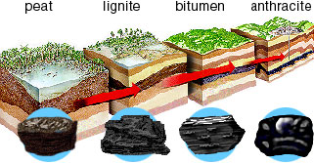
As for the commodity mined, the grade actually differs with different depths and the grade actually increase with depth. Probably when considering this fact there is a slight contrast between the coal from underground and the coal from open-cast considering their variations in depth. The diagram below shows how coal may vary in quality with depth of burial.

Figure 2
As coal becomes buried more deeply, it goes through a sequence of changes in rank: from peat, to lignite, sub-bituminous coal, bituminous coal, semi-anthracite, and anthracite. This process results in irreversible changes in the chemical and physical nature of the coal, and there can be considerable variation within a coalfield. Geological age does not affect rank (Major, 1996). From peat to bituminous coal there is a loss of water but a proportionate increase in carbon. Lignite and sub-bituminous coal are relatively soft, with a brown, earthy appearance – they are often known as brown coals. Higher-rank coals are blacker, shinier, and have a higher proportion of carbon. As the rank increases, so does the heat (or calorific value) given out by the coal when it bums. It is difficult to make a fire from lignite because the moisture content is so high. Sub-bituminous coal burns satisfactorily, and bituminous coal burns fiercely (Major, 1996).
- Production operation
The production operation consist of all activities that directly contribute to production but in relation also the auxiliary operation of this mine will be discussed as part of the production operation. As the mine as the whole operation is consist of both surface and underground operation, at the open-cast operation no slope stabilization is required since the rocks that are encountered are sandstone and shale which are both mature; water at the pit is not actually disturbing the production since the water is pumped regularly; other waste materials are dumped around the pit producing sort of a hump that is called the safety beam that helps other materials not to fall into the pit and coal is crushed and loaded in trucks of either 30 tons or 50 tons in capacity and transported to the processing plant; at underground operation it is actually crushed or otherwise excavated and loaded to a conveyor belt that haul it to the surface, and therefore loaded to the processing plant. The crushing (even of waste with the idea to recover the mined commodity) is furthered at the processing plant to produce different sizes of this coal for screening at which the required grade is selected necessarily the coal is crushed at different sizes according to the supply to the market. The crushed coal is then washed finally with water mixed the magnetite powder.
The water that is used for coal washing is disposed to the pollution control dams whilst another is re-used to wash coal again, the mine operation as a whole has three pollution control dams that actually operate in pair’s i.e. the two can operate simultaneously while the other is under cleaning (dams are actually cleaned on regular basis) or maybe repair in which the water that was contained in it is pumped to other dams to ease the control. The slurry in the water is left to sink to the bottom of the pollution control dam and no water treatment facilities are in place at current as the operation itself is a close system at which rain water is also harvested to meet the mine’s water needs.
The health and safety at this mine is kept up to standard especially in the premises of the underground operation where the instrument called G333 Tester is used to detect volatile gases and dangerous gases associated with coal and the general target gases include methane CH₄ at levels of 1% (detectable by the tester), 1.4% (warning concentrations- evacuation may be recommended at this level) and 5% (this is the dangerous level that if detected, response should be immediate); carbon monoxide CO at levels starting at 100ppm(detectable by the tester), 110ppm(warning concentrations- evacuation is recommended), 999ppm(dangerous level); and in some cases oxygen is also tested. The rock bolts are used to support the roof and narrow tunnels are in line to minimize the support required and the cost of tunneling.
- Conclusion
Although the coal seams differs in both thickness and quality, and no available specific tons has been estimated, the mine is expected to remain operating at a period of 12 years at which it has been operating for three years and has achieved much in terms of revenue considering that two pits have already ceased operating and are backfilled as part of mine rehabilitation to retain the ground to acceptable general standards. Also the mines as a whole have provided us with much experience considering that it both has the underground and surface operation. The stratigraphy of the area as well presents less difficulties in the mining operations of the area.

- Recommendations
Since the area is located with the sensitive areas, a continual improvement in mine water management is required to meet the quality standard acceptable to the surrounding area. The regular quantification for the existing coal seam must be undertaken in order to determine grade, quality and the estimated tons available according their rendered quality and thickness. The roads especially at the opencast pit must be improved to fit or otherwise suit all conditions i.e. both dry conditions and rainy conditions. The reprocessing of the waste is more advisable to be considered at a greater practice and therefore extend the lifespan of the mine as an operation. Installation of water treatment plants is also recommended especially when considering the lifespan of the mine. Scientific research can be also conducted in this in the area to try to understand the surrounding response for the coming years of the existing mine’s lifespan.

- References
Major, T. (1996). Genesis and the origin of coal and oil, 2nd ed. Apologetics Press, Inc., U.S.A.
Smith, D.A.M and Whittaker, R.R.L.G. (1986). The coalfields of Southern Africa: An introduction; In: Anhaeusser, C.R. and Maske, S. (Eds.), Mineral Deposits of Southern Africa. I, Geological Society of South Africa, pp 1875 – 1878.
Smith, D.A.M. and Whittaker, R.R.L.G. (1986). The Springs – Witbank Coalfield; In: Anhaeusser, C.R. and Maske, S. (Eds.), Mineral Deposits of Southern Africa. I, Geological Society of South Africa, pp1969 – 1984.

