School of Environmental Sciences
Department of Mining and Environmental Geology
DISCUSSION OF PLATE TECTONICS IN RELATION TO ORE FORMATION

STUDENT NUMBER | 11602169
FULL NAMES | MBEDZI ADAM
COURSE | MEG3641: EXPLORATION AND MINING GEOLOGY
LECTURER | PROF. J.S. OGOLA

CONTENTS
- Introduction…………………………………………………………………………………………… 2
- Ore formation and plate tectonics………………………………………………………….. 2
  - Divergent plate margins…………………………………………………………………… 3
  - Convergent plate margins………………………………………………………………… 4
  - Cratonic rift systems………………………………………………………………………… 5
  - Cratonic basins…………………………………………………………………….............. 6
- Conclusion………………………………………………………………………………………………. 7
- References……………………………………………………………………………………………… 8

- Introduction
The earth’s crust is broadly divided into continental crust of approximately granitic i.e. felsic in composition and oceanic crust of roughly basaltic i.e. mafic in composition. The characteristics of earth’s crust are largely the direct or indirect result of motions of the lithosphere. The theory of plate tectonics describes these motions and accounts for most observable tectonic activity in the earth and the tectonic history recorded in the ocean basins (Moore et al, 1995).
Tectonic plates are composed of oceanic lithosphere and thicker continental lithosphere, each topped by its own kind of crust. Along convergent boundaries, subduction carries plates into the mantle; the material lost is roughly balanced by the formation of new oceanic crust along divergent margins by seafloor spreading. Tectonic plates are able to move because the earth’s lithosphere has a higher strength and lower density than the underlying asthenosphere. The key principle in plate tectonics is that the lithosphere exists as separate and distinct tectonic plates, which ride on the fluid-like (visco-elastic solid) asthenosphere (Winter, 2010).
- Ore Formation and Plate Tectonics
Plate tectonics correspond to crustal evolution in providing the basis in understanding the distribution and origin of mineral and energy deposits. Plate tectonics is the underlying mechanism for generating vast majority of ore deposits. The relationship of plate tectonics and mineral deposits is significant on three grounds:
- Geological processes operating due to energy released at plate boundaries control the process of mineral deposition. These include the internal processes to magma such as fractional crystallization and liquid immiscibility, hydrothermal processes (these processes are the physico-chemical phenomena and reactions caused by movements of fluids within the crust, often as a consequence of magmatic intrusion or tectonic upheavals); and metamorphic processes.
- Mineral deposits form in particular tectonic settings which are governed by plate tectonics such as oceanic ridges, rift valleys and others.
- Reconstruction of fragmented continents can provide a useful basis for exploration of new mineral deposits.
A plethora of requirements must be fulfilled in any tectonic setting for the production and accumulation of minerals. Most of the tectonic settings meet these requirements and below is a diagram showing different tectonic settings that are likely to meet these requirements.

Figure 1: Tectonic setting meeting different requirements of mineral segregation.
  - Divergent plate margins
Divergent boundary occurs where two plates slide apart from each other; and appears on the crust (oceanic or continental) as mid-oceanic ridges such as Mid-Atlantic Ridge and active zones of rifting such as Africa’s East African Rift Valley.

Hydrothermal activity at the ridges results in a) Sulfide deposits and b) Metalliferous sediments on the flanks of ridges. Important metallic deposits formed are Fe, Zn, Cu, Pb, Au and Ag. In the Red Sea metalliferous sediments containing Fe, Zn and Cu are being deposited. Mn oxide deposits are important at some ridges e.g. the hydrothermal field on the Atlantic Ridge. Ultramafic rocks in ophiolites containing asbestos, chromite and nickel ores (Simon et al, 2011).
These are generally accessible in Phanerozoic orogenic belts to which sites they have been transported due to plate movement. Podiform chromite deposits associated with serpentinized ultramafic rocks. Cyprus Type massive sulfide deposits (Cu-Fe rich) are also associated with ophiolites and represent hydrothermal deposits formed at ocean ridges (Simon et al, 2011). Several types of mineral deposits appear to show a genetic relationship to either the hot mantle plume itself or the tracks it produces and this is illustrated in figure 2 in the next page.

Figure 2: Different ore deposits associated with different tectonic settings.
  - Convergent plate margins
Metallic deposits are commonly found at both continental and arc convergent plate margins. Along the Circum-Pacific Belt major metallic deposits occur in western North and South America, Japan, Philippines, New Zealand and Indonesia. Above half of the world's supply of copper comes from Porphyry Copper Deposits of this region. Important deposits associated with present and former convergent margins are:
- Base metals (Cu, Pb, Zn, Mo).
- Precious metals (Pt, Au, Ag).
- Other metals (Sn, W, Sb, Hg).
Zoning of mineral deposits forming at convergent margins is apparent e.g. in the Andes, going from west to east, the various zones encountered are:
- contact metasomatic Fe- deposits;
- Cu-Ag and Ag veins;
- Porphyry Cu-Mo deposits;
- Pb-Zn-Ag veins and contact metasomatic deposits; and
- Other metals such as Sn deposits.
These zones are due to progressive liberation of metals from descending slab, with Sn coming from a depth of about 300 km (Simon et al, 2011). These metals are derived from some combination of the descending slab and the overlying mantle wedge. They move upwards in magmas or fluids and are concentrated in late hydrothermal and magmatic fluids. Petroleum occurs in the back-arc basins in arc convergent margins where organic matter is trapped and there is a lack of free circulation so that its oxidation is prevented. Geothermal heat facilitates conversion of organic matter to petroleum, and accompanying deformation forms traps for accumulation of petroleum. Potential geothermal fields also occur along convergent margins.

  - Cratonic rift systems
Regional uplift and doming usually result when a continent comes to rest over a hotspot and huge volumes of magma rise to the surface. Extensional failure of the lithospheric crust may occur with continued doming, triggering the development of a triple junction - a three armed continental rift system. Typically, one arm of the rift fails remaining a fissure in the crust known as an aulacogen, while the remaining two arms open to form an oceanic basin. The prevalence of three armed rifts is revealed by reassembling the continents surrounding the Atlantic Ocean to their positions before Pangea split up. In most cases two of the arms were incorporated into the Atlantic, while the third remained as a blind rift extending into the continent (Dixon et al, 1974).
Rifting follows crustal doming in response to hot-spot activity in the mantle.
- Granites intruded at this stage have associated Sn and fluorite deposits.
- Evaporites accumulate in the rifts during the more advanced stages, with Pb-Zn-Ag deposits in limestones forming during the early and middle stages of rifting. These are followed by oceanic metalliferous deposits.
- Aulacogens are characterized by the presence of fluorite, barite, carbonatites (with Nb, P, REE, U, Th etc.) and Sn-bearing granites.
- Geothermal fields occur along the rifts due to the upwelling of the asthenosphere.
- Carbonatites (unusual igneous rock rich in calcite and other carbonate minerals which are considered to be mantle derived), kimberlites, and alkaline granites within or adjacent to rifts provide a major source of metallic and other minerals.
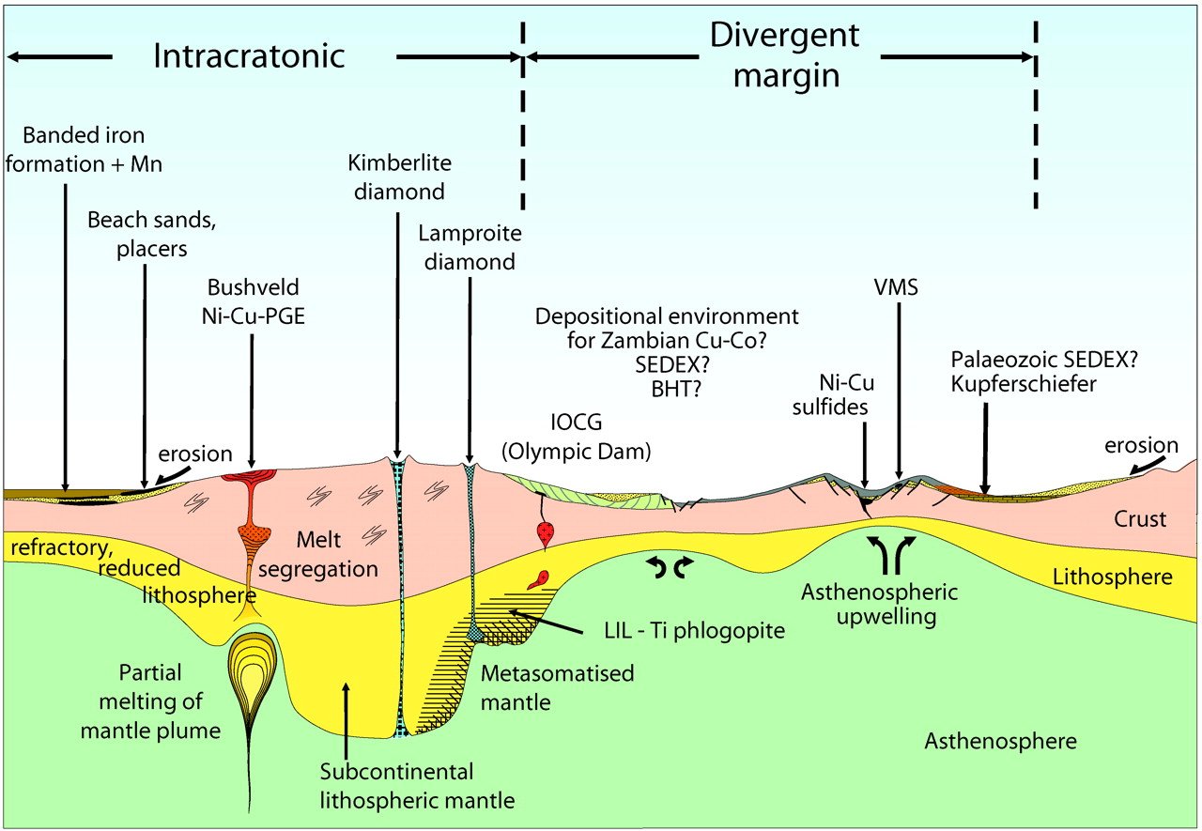

Figure 3: Cratonic tectonic setting and its associated mineral deposits

  - Cratonic basins
Marginal and intracontinental cratonic basins provide a favourable setting for accumulation of organic matter. During the opening of a cratonic rift, seawater moves into the basin and evaporation exceeds inflow, giving rise to the formation of evaporites. The environment is characterized by restricted circulation and hence organic matter is preserved leading to the accumulation of petroleum. With continued rifting, circulation becomes unrestricted and deposition of evaporites and organic matter ceases.
High geothermal gradients beneath the opening rift and increase in pressure due to burial by sediments facilitate the conversion of organic matter to petroleum. In the final stages of the opening of the basin, the salt beds may begin to rise as salt domes forming traps for oil and gas. Oil and gas may also be trapped in structural and stratigraphic traps as they move up due to increasing temperature and pressure.
This speculation is lent support by the fact that around the Atlantic there is a close geographic and geologic relationship between hydrocarbons and salt accumulations. Below is a diagram showing other deposits that are associated with basin environments as a result of tectonic activity.

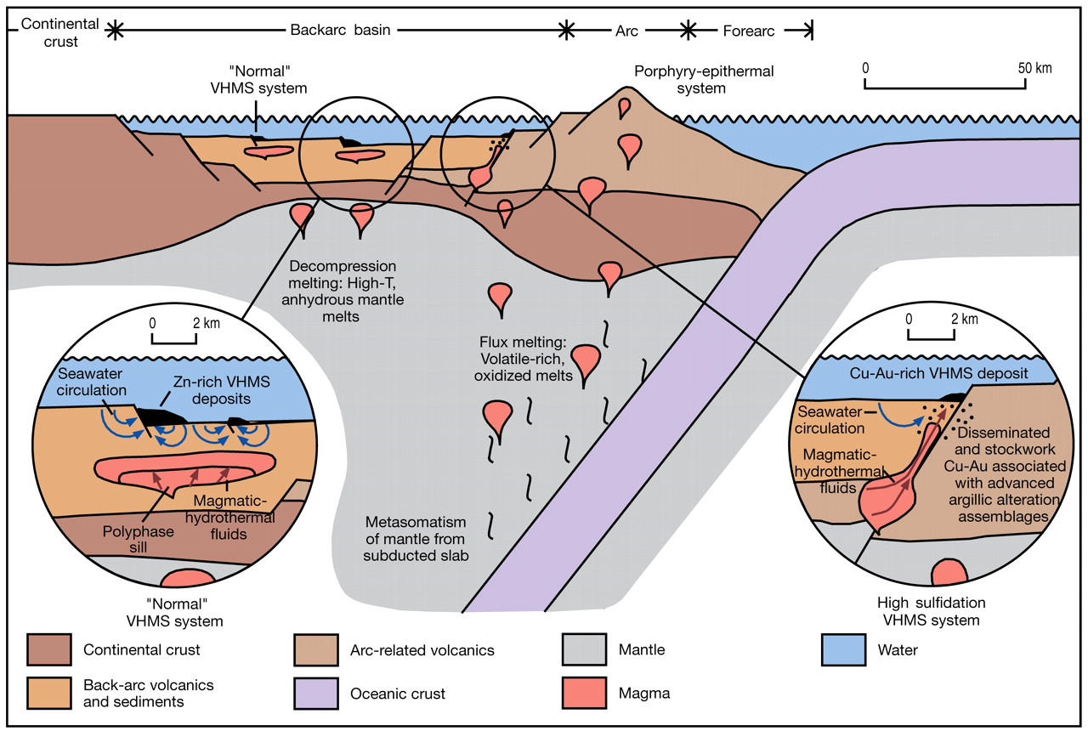
Figure 4: Basin environment and related deposits.

- Conclusion
Plate tectonics is the main mechanism of ore formation although there are other secondary processes that can lead to the accumulation of mineral deposits, this is because most ore formation processes requires special conditions such as very high temperatures for diamond formation and such conditions are met at a very great depth beneath the earth’s surface; and therefore requires the mechanisms of plate tectonics to drive them into a near surface regions of the earth’s crust. Most importantly, most of the ore forming elements have a relatively low abundance on the earth’s crust and are situated deep in the earth and therefore require plate tectonic mechanisms to bring them to near surface.

The plate tectonics involves many processes such as orogenic and metamorphic which are also responsible for the accumulation of ore deposits in different environments such as hot spots. Volcanic activity is also a tectonic related process that can be responsible for the formation of ore deposits.

- References
Dixon, C. J. and Pereira, J. (1974). Plate Tectonics and Mineralisation in the Tethyan region. vol.9, Issue 3, Mineralium Deposita, SPRINGER, pp185 – 198.

Moores, E. M. and Twiss, R. J. (1995). Tectonics. W. H. Freeman Company, New York.

Sillitoe, R. H. (2008). A Plate Tectonic Model for the Origin of Porphyry Copper Deposits. American Geological Institute, U.S.A.

Simon, A. C. and Ripley, E. M. (2011). The Role of Magmatic Sulfur in the Formation of Ore Deposits. American Geological Institute, United States of America.

Winter, J. D. (2010). An Introduction to Igneous and Metamorphic Petrology. 2nd ed., Prentice Hall, New York.

Wyllie, P. J. (1988). Magma genesis, plate tectonics and chemical differentiation of the Earth. Reviews of Geophysics, 26, 370 – 404.

