Schlumberger Array
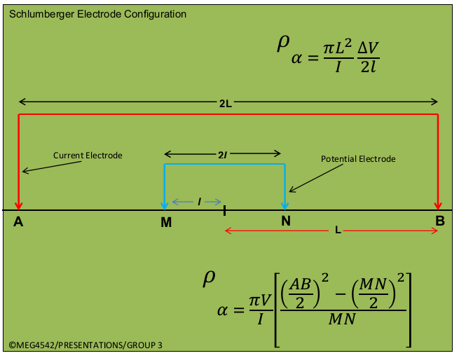
In this array, four electrodes are placed along a straight line in the same order AMNB, but with AB ≥ 5MN where A and B are current electrodes and, M and N are potential electrodes.
Figure 1

Vertical Electrical Sounding
In vertical sounding, the potential electrodes remain fixed while the current electrode spacing is expanded symmetrically about the centre of the spread. For large values of (L) it may be necessary to increase (l) also in order to maintain a measurable potential. This is to say, potential electrodes are moved only occasionally, and current electrode are systematically moved outwards in steps AB ≥ 5MN.

Horizontal Electrical Profiling
Lateral profiling maybe done in two ways. With a very large fixed separation of the current electrodes (300 m or more), the potential pair is moved between them. The other layout is similar to the Wenner in that the electrode spacing remains fixed (L˃˃l) and the whole array is moved along the line in suitable steps. This arrangement is less convenient than the first because it requires that all four electrodes be moved for each station.
Schlumberger Array/Electrode Configuration
Advantages | Disadvantages
- Fewer electrodes to move each sounding. | - Can be confusing in the field.
- Needs shorter potential cables. | 2 Requires more sensitive equipment.
 | - Long current cables.

